**Types of Operating System**

**Batch Operating System**

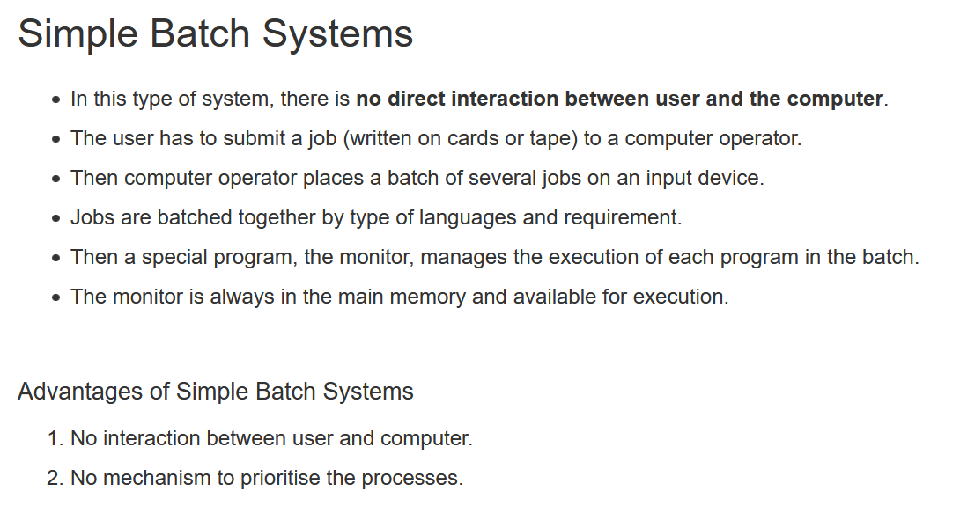



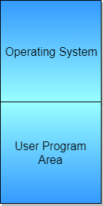

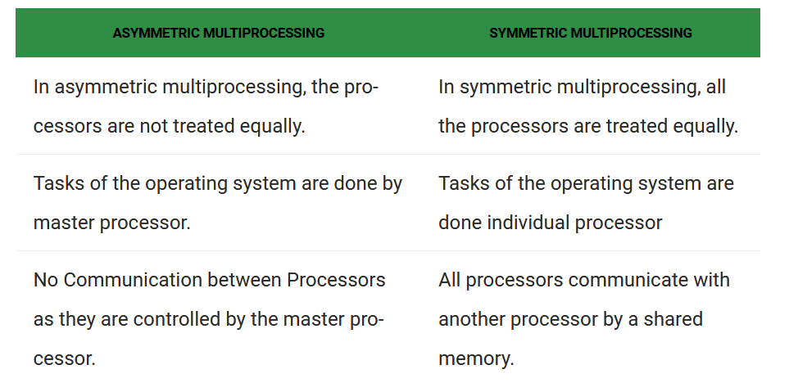  
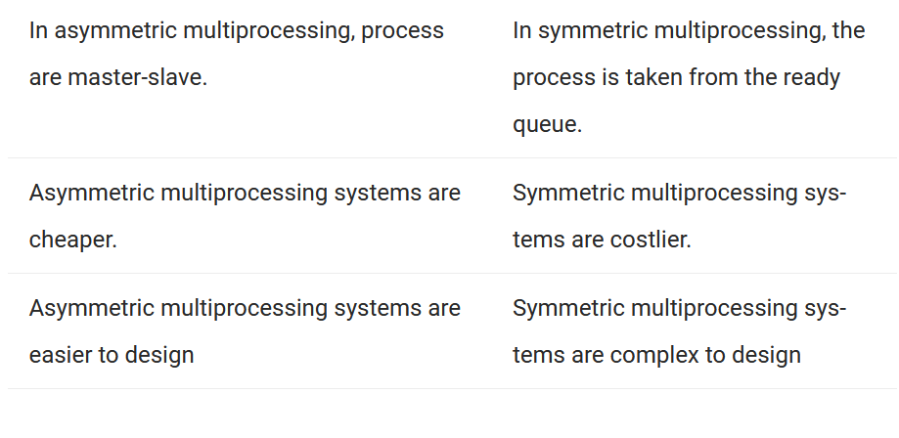

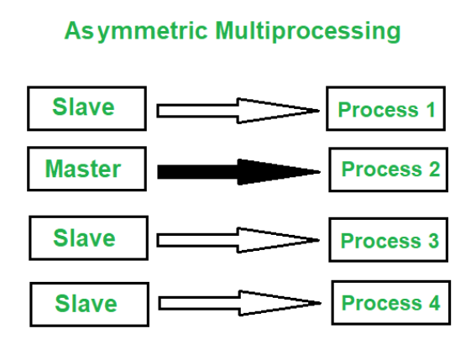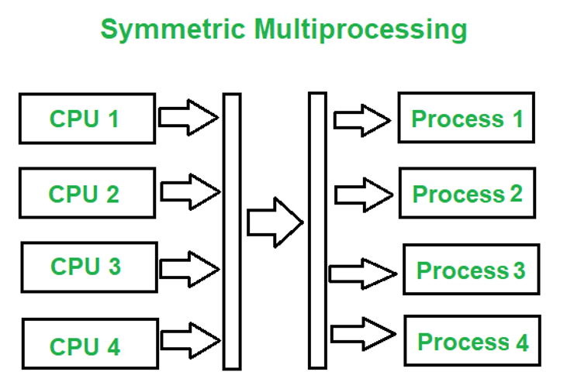

**Symmetric:**

Processor-1 : 10 min

Processor-2 : 5 min

After Processor-2 finishes it does not sit idle, it takes the work from Processor-1 and do that work. No head for scheduling the processor to do 🡪 Present technology

**As-symmetric :**

Processor-1 : 10 min

Processor-2 : 5 min

A head will be there to schedule the processor.

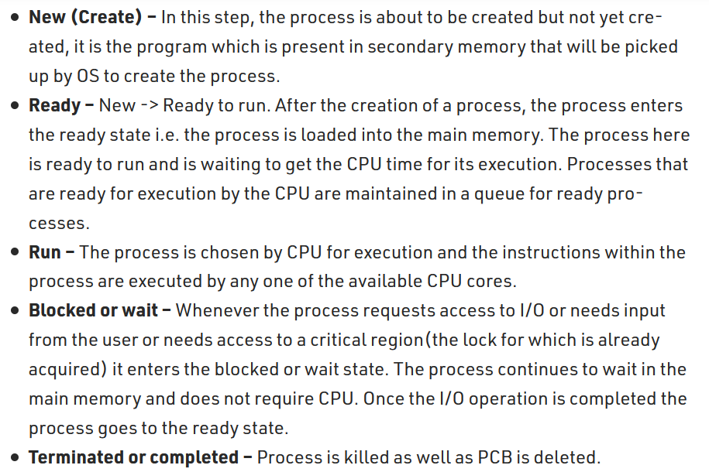

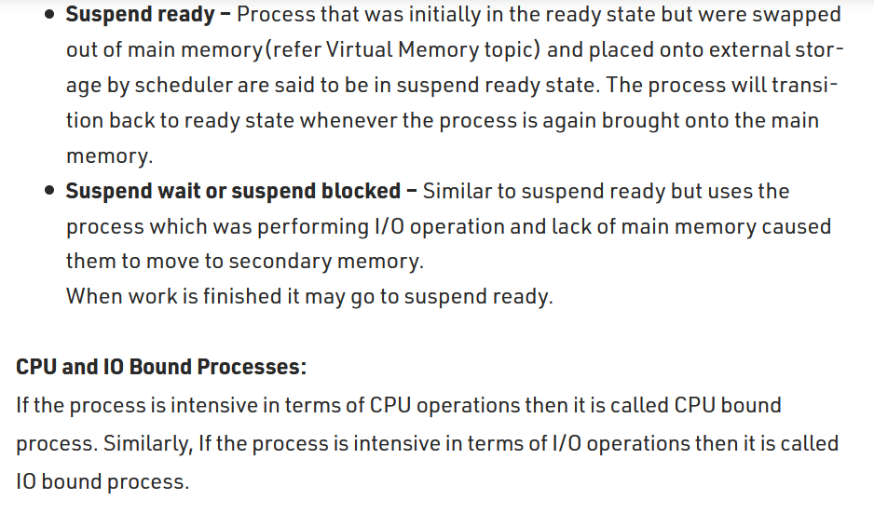

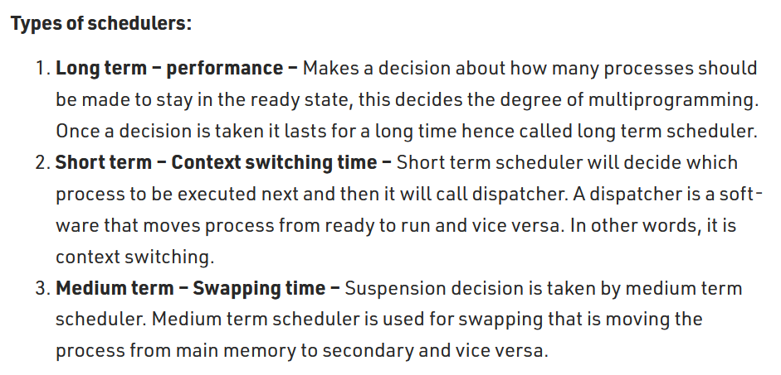



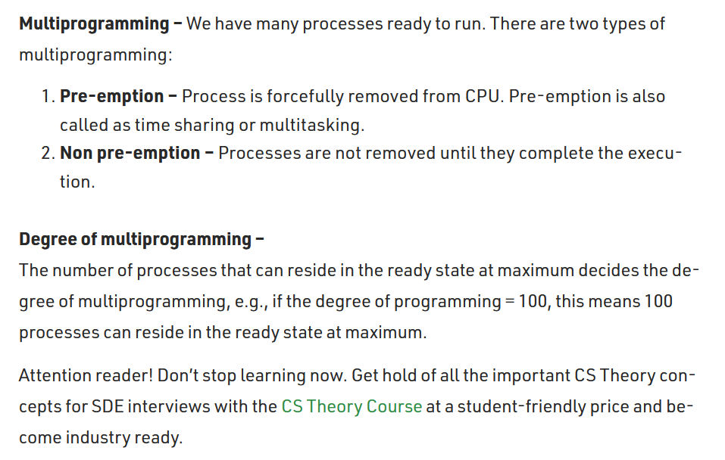

User Mode and Kernel Mode

